UNIVARIATE ANALYSIS
Central Tendency:
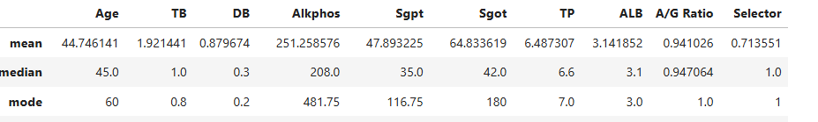
From the table, The analysis of the average age of the patient is 44 by ‘mean’ and most of the patient in 60’s by ‘mode’ function.

Outliers:
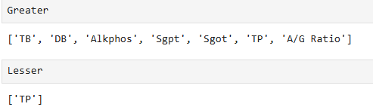
- The outliers value of features in dataset.
- To detect by IQR and replacing the value.
- If the value in dataset is less than lesser, replace the ow outliers
- If the value is greater than greater outlier, replace the high outliers.
Replacing the outliers:
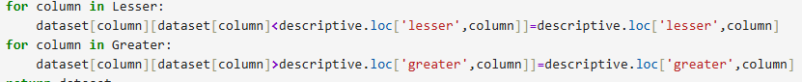

Finding and Replacing NullValues:
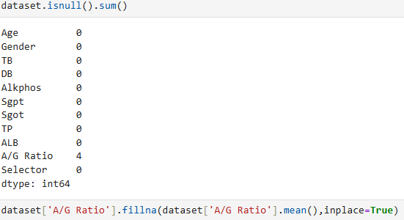
- Replacing the null values by mean to fill Nan values.
- The dataset should be without outliers and Nan values, if not the model couldn’t show the accuracy result.

Standard Normal Distribution:
- It standardize (define range) the data for analysis by Z_score
- Here mean is always 0 and standard deviation is 1.
- Z_score is the test only for univariate analysis. It converts the normal distribution into standard normal distribution

